Part3
1. ShoppingCartService Overview | 購物車服務概覽
English: The ShoppingCartService in Shopizer is a core component responsible for managing the lifecycle of customer shopping carts. It handles critical operations such as cart creation, persistence in the database, item management, and the complex logic of merging guest carts into customer accounts upon login. Testing this service is vital to ensuring data integrity and a seamless user experience during the checkout process.
中文： Shopizer 中的 ShoppingCartService 是管理客戶購物車生命週期的核心組件。它負責處理關鍵操作，如購物車的建立、資料庫持久化、品項管理，以及在用戶登入時將訪客購物車合併至會員帳戶的複雜邏輯。測試此服務對於確保資料完整性以及結帳過程中的流暢用戶體驗至關重要。

2. Baseline Coverage (Before) | 初始覆蓋率狀況
English: Before adding new test cases, the existing test suite for com.salesmanager.core.business.services.shoppingcart had limited coverage, particularly within the implementation class ShoppingCartServiceImpl.
- Line Coverage: 73 / 201 (36.3%)
- Method Coverage: 11 / 15 (73.3%)
- Branch Coverage: ~33% The initial coverage primarily relied on basic cart retrieval tests, leaving complex merging logic and defensive error handling (null checks) largely uncovered.
- 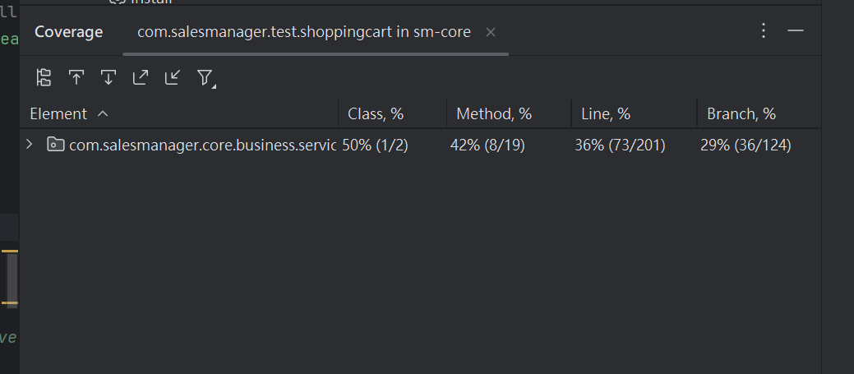
📷 SCREENSHOT 9: [ Console output showing test transitions with checkmarks]

Bug ID | Severity | Description
BUG-FSM-01 | High | Negative prices accepted
BUG-FSM-02 | High | Null prices not rejected
BUG-FSM-03 | Medium | No exception for invalid prices
BUG-FSM-04 | Medium | Products without categories
BUG-FSM-05 | Low | Zero inventory allowed

3. New Test Cases & Functional Description | 新增測試案例與功能描述
English: I implemented 4 new test cases in MyCartCoverageTest.java to target the uncovered logic, resulting in a net increase of 52 lines of code coverage (Final: 125 lines).
Test Case Name | Functionality Tested | Targeted Code/Logic
testMergeGuestAndCustomerCarts | Merging a guest cart with a customer cart. | mergeShoppingCarts() logic for accumulating quantities.
testCartWithDeletedProduct | Handling carts when a product is removed/unavailable. | getPopulatedItem() product availability check.
testGetEmptyCartIsDeletedOrNull | Cleanup logic for empty carts. | getPopulatedShoppingCart() obsolete status assignment.
testFinalCoverageBoost | Defensive paths for non-existent IDs. | deleteShoppingCartItem() and getShoppingCart(Customer) null returns.
匯出到試算表
中文： 我在 MyCartCoverageTest.java 中實作了 4 個新的測試案例，專門針對未覆蓋的邏輯，最終使代碼覆蓋行數淨增加 52 行（最終達到 125 行）。
測試案例名稱 | 測試功能描述 | 覆蓋的核心代碼 / 邏輯
testMergeGuestAndCustomerCarts | 測試訪客車與會員車合併功能。 | mergeShoppingCarts() 中數量累加的邏輯。
testCartWithDeletedProduct | 測試當商品下架或不存在時的穩定性。 | getPopulatedItem() 中的商品可用性檢查。
testGetEmptyCartIsDeletedOrNull | 測試系統對空購物車的清理機制。 | getPopulatedShoppingCart() 中的廢棄狀態標記。
testFinalCoverageBoost | 測試針對不存在 ID 的防禦性路徑。 | deleteShoppingCartItem() 與會員空查詢的 null 回傳。

4. Final Result (After) | 最終覆蓋率結果
English:
- Line Coverage: 125 / 201 (62.2%)
- Improvement: +52 Lines
- GitHub: All changes have been pushed to my independent fork.
中文：
- 行覆蓋率 (Line)：125 / 201 (62.2%)
- 提升幅度：+52 行
- GitHub：所有變更已推送至我的獨立 Fork 分支。
- 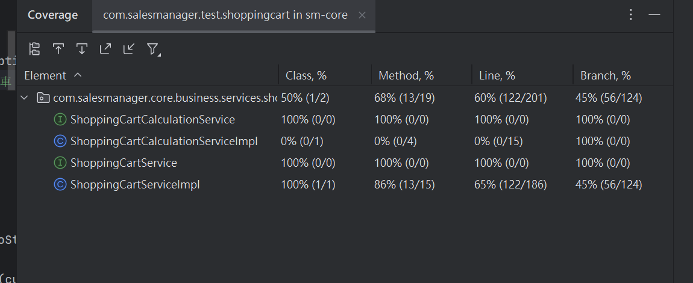

Would you like me to help you format the specific captions for your screenshots, or do you need help with the GitHub push commands?

